**Component 1: Checklist**

**Student Name/ID: Pratik Regmi/77297967**

**Development Choice: PHPStorm / XAMPP**

**PHPStorm / Vagrant**

**Eclipse Che**

**Other vscode,xampp**

**IDE used – Vs code**

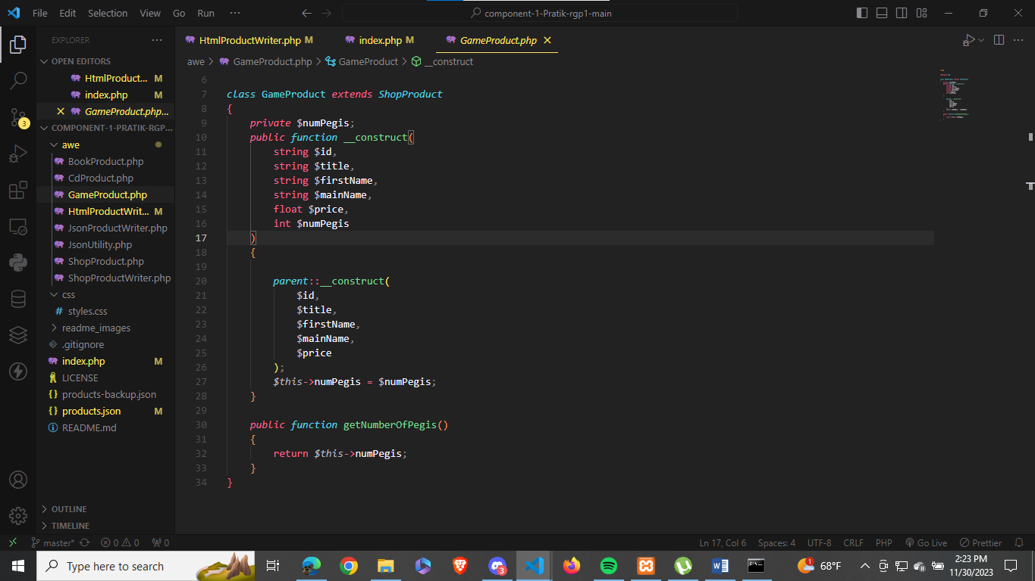

**Xdebug installed in vs code**

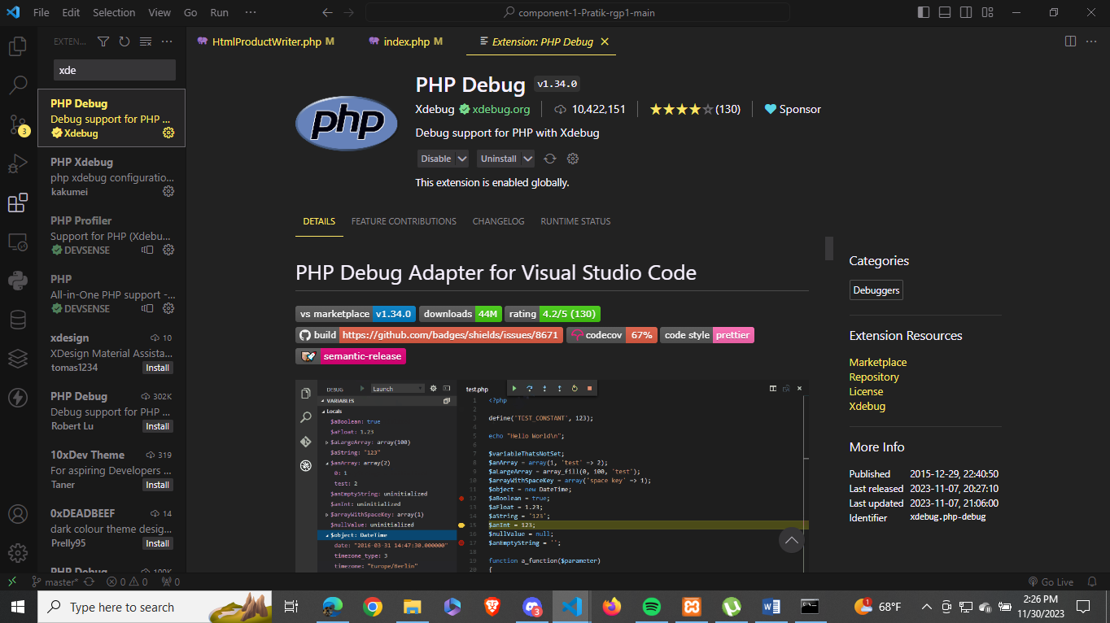

**PHP Version being used: ‘8.2.11’**

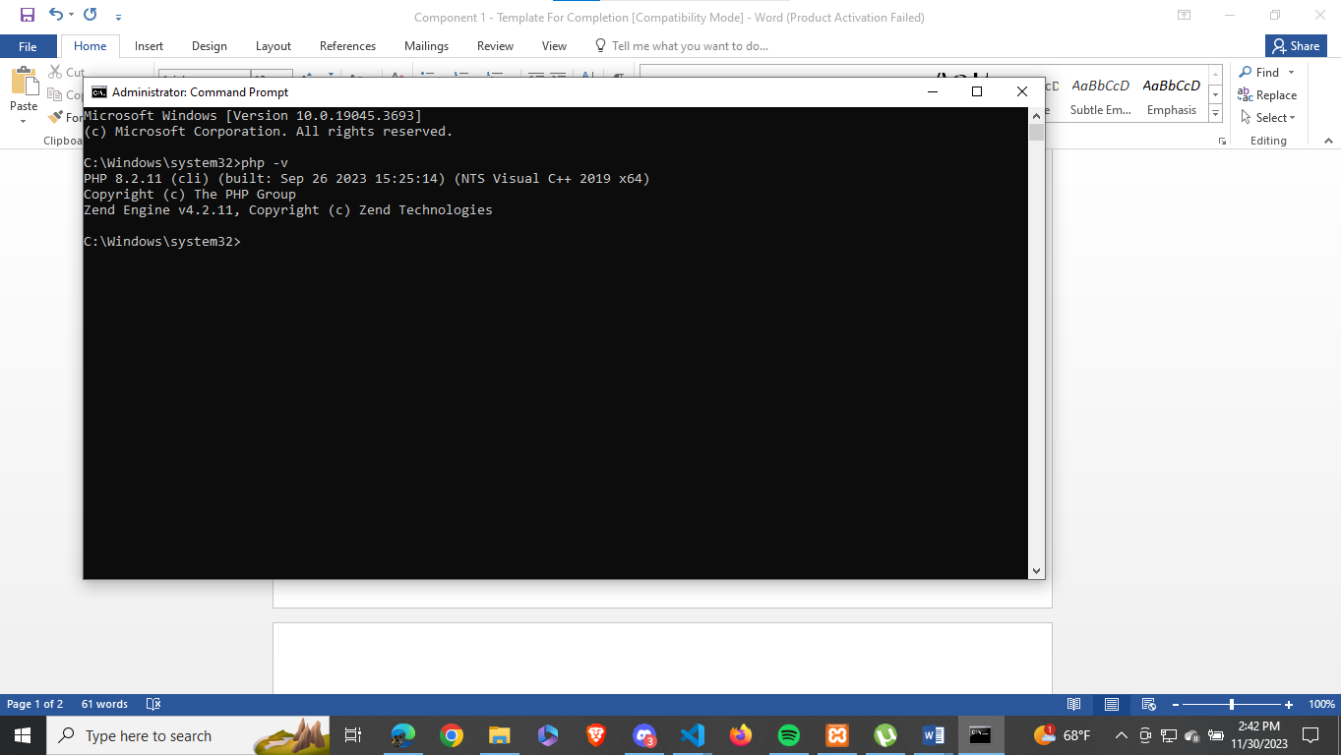

**Xampp version(apache and mysql)**

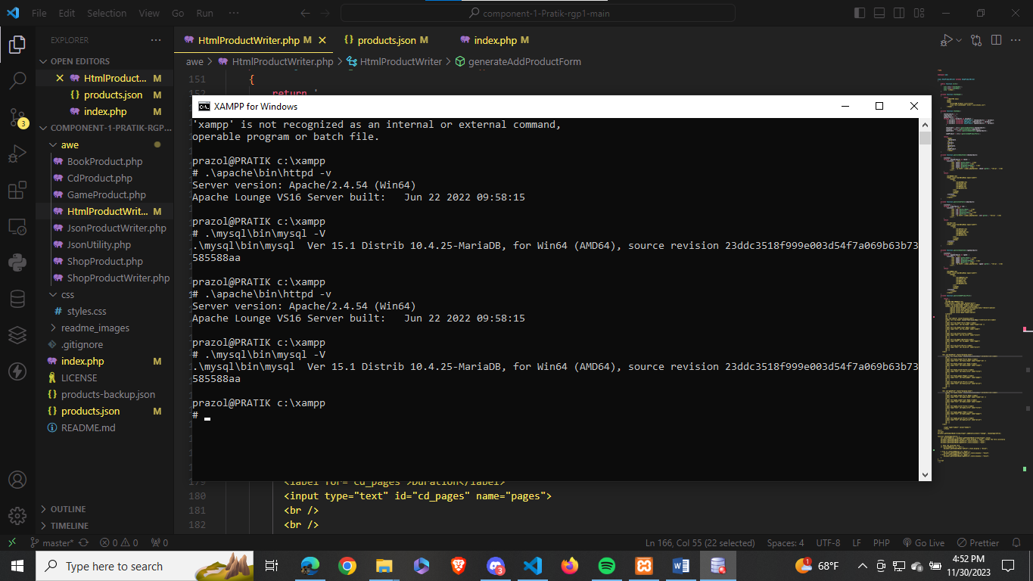

**Git account created and used: ‘**[tbc-bsc-l6/component-1-Pratik-rgp1: component-1-Pratik-rgp1 created by GitHub Classroom](https://github.com/tbc-bsc-l6/component-1-Pratik-rgp1)**’**

**https://github.com/comp-bkt/component-1-Pratik-rgp1.git**

**Game table created with the addition of PEGI field.**

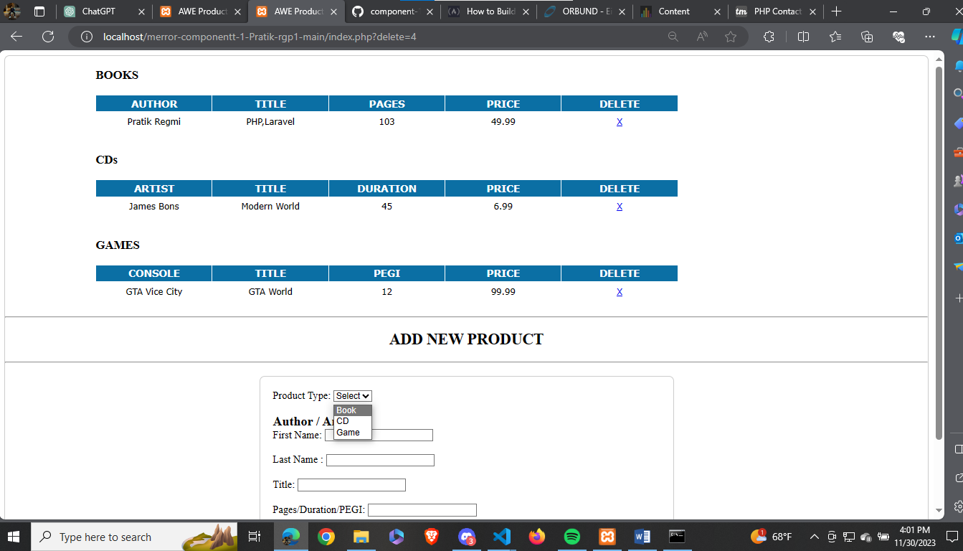

**Some products added to the CD and Game Table**

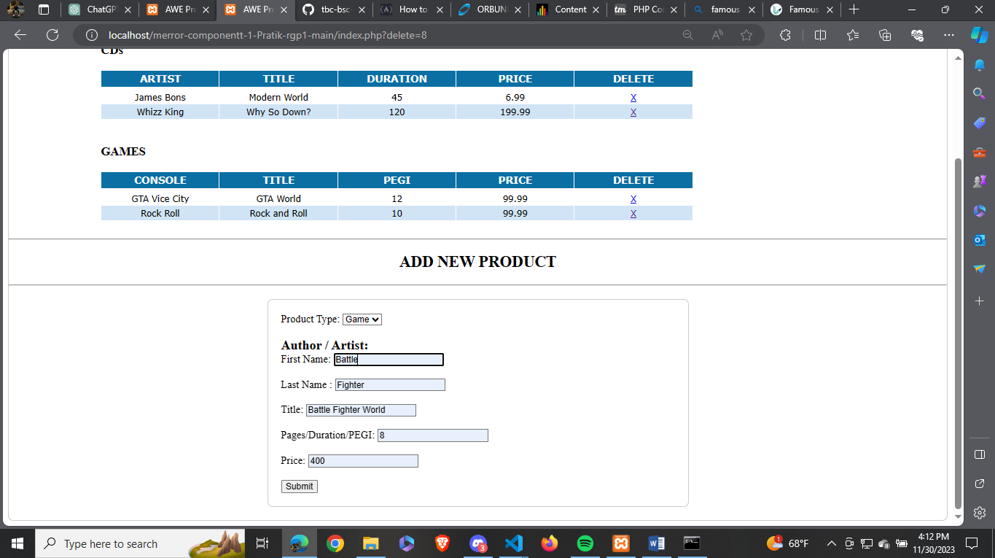

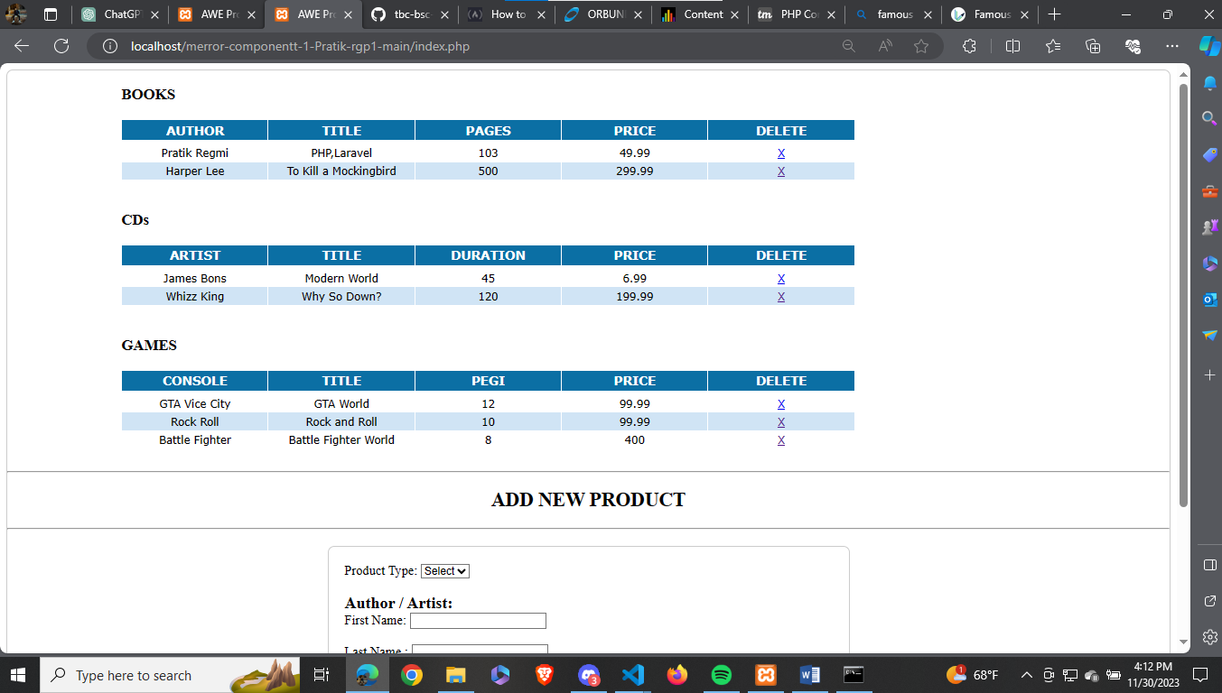

**Some changes made in code:**

1. **GameProduct class is created:**

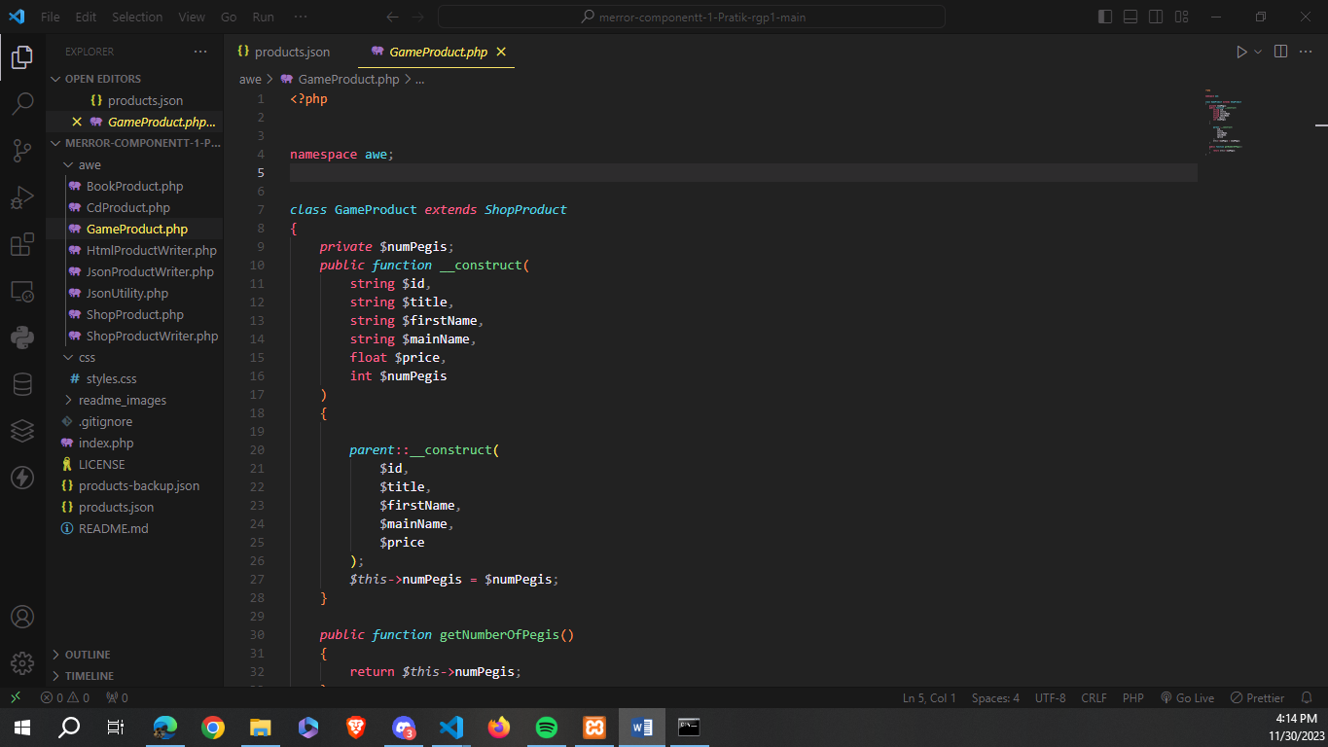

1. **Game table is generated.**

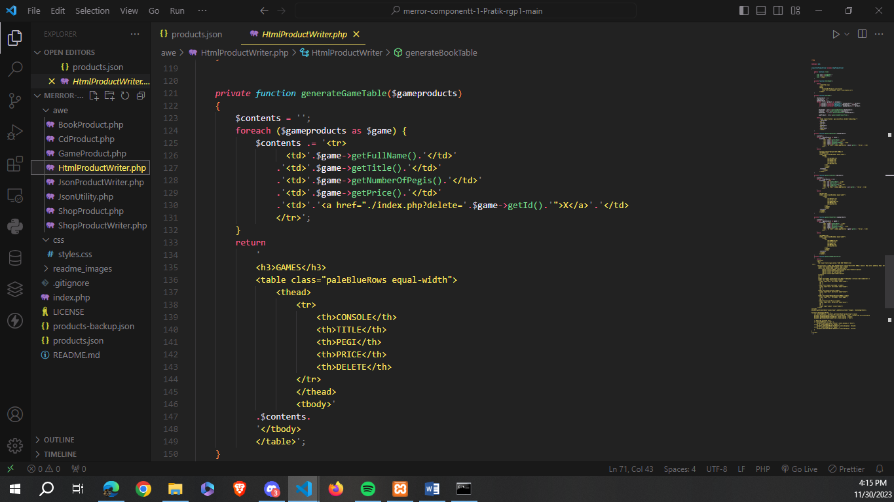

**Some changes in the style of form done**

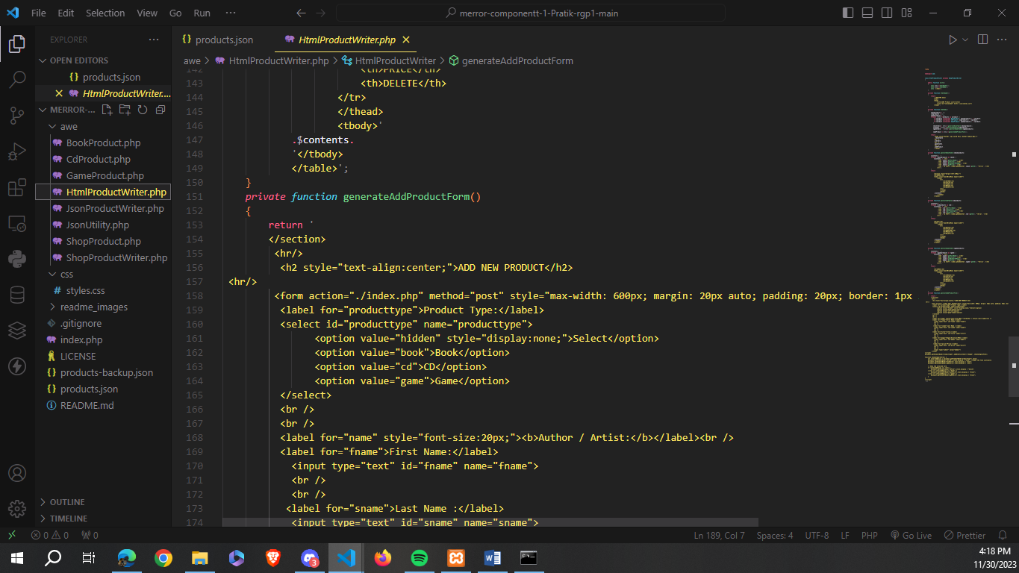

1. **$product is an instance of GameProduct class(.added)**

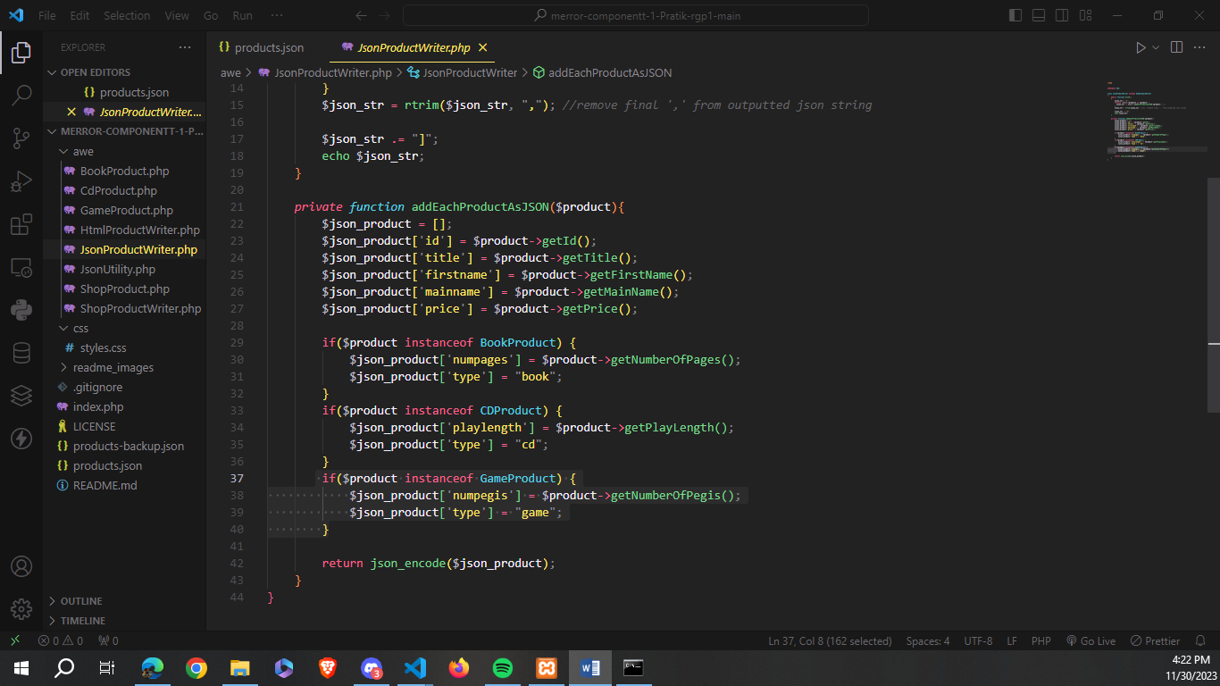

1. **In JsonUtility.php switch case for product type-game is added.**

